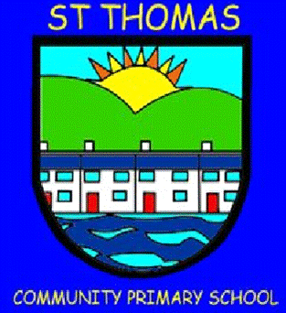
St Thomas Community Primary School
Newsletter
Summer Term 1, 2025 Issue 65 – 23/05/25
Head Teacher’s Message

It’s been a busy half term, with a bank holiday thrown in! As you can see with the list of dates in this newsletter, our next half term will be busy too! I hope you all have a lovely half term and we will see you very soon!

Best wishes,

Road Safety Assemblies

The safety of our pupils is the most important part
of our day to day running and we recently had
assemblies helping the children understand how to
stay safe on the roads. We discussed different
types of crossings and how to cross the road safely. We also discussed how to improve the road safety of our local area and will be monitoring this situation closely with our local PCSOs.

Year 6 VE Day Celebrations

To commemorate the 80 anniversary of VE Day, our Year 6 children participated in a joint celebration with Danygraig Primary School. This included reading and reciting poems as well as meeting important dignitaries such as the Mayor, HM Lord Liuetenant for West Glamorgan and West Glamorgan‘s High
Sherrif. The children also
had the fantastic
opportunity of meeting
two WW2 veterans who
were 99 and 101 years old!
The children asked them questions of their
experiences and the answers were phenomenal! We even had the privelege of being filmed for ITV news and some pupils were even interviewed!

Year 4 – Kilvey Hill

This week, our Year 4 children had a great experience of walking to the top of Kilvey Hill. We are so lucky to have such wonderful opportunities so close to us and the children were fantastic. They completed sketching at the top, as well as discussing an appreciciation of beauty. Da iawn, pawb!

Year 1 – My School is at the Museum

We were delighted to resume our
residency opportunity at the
Waterfront Musuem, with our Year 1
children this time. The children had
a great time and it was lovely to
invite families to join them at the end. The children also had the opportunity to explore outside the museum. A big thank you to the museum and to our Year 1 families for supporting us.

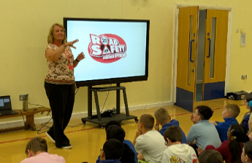

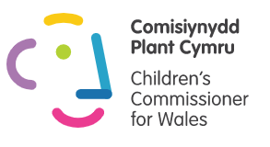

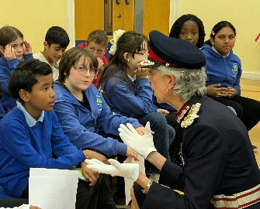

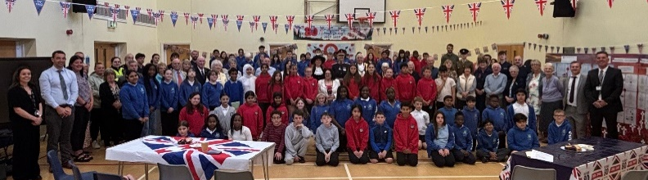

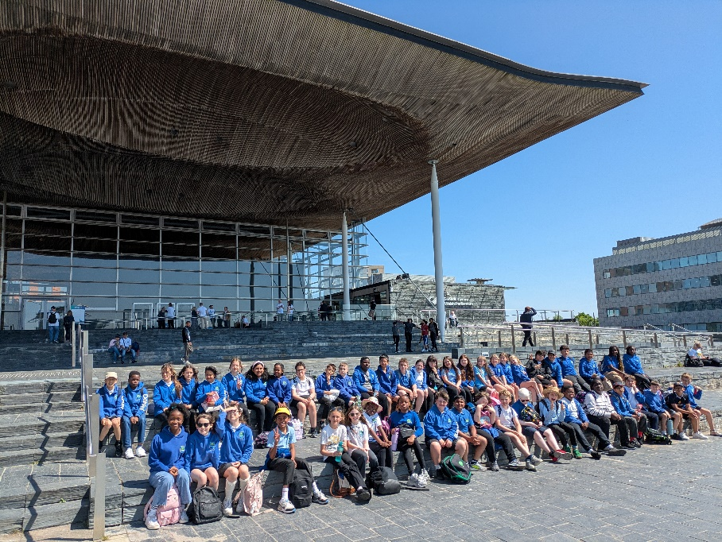

We support Children’s Rights and the UNCRC.

Get regular updates on the Dojo app.

St Thomas Community Primary School
Newsletter
Summer Term 1, 2024 Issue 65 – 24/05/24

Cardiff Senedd Visit

Our Cardiff trip was a fantastic day! The children got a tour of the Senedd including the main debating chamber and media rooms. We also met Jeremy Miles, MS, Cabinet Secretary for Health and Social Care, and asked him important questions about our area. We then finished off with a walk around Cardiff Bay!

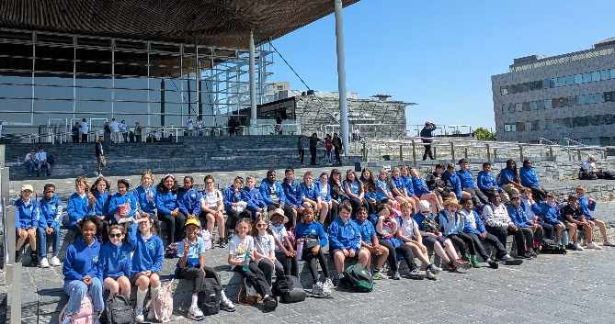


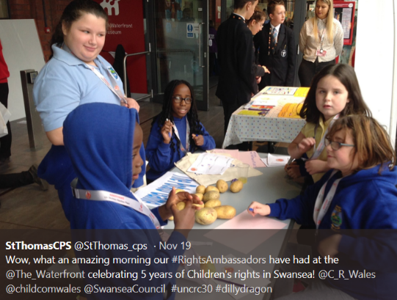

Important Dates
Half Term – Monday, 26th May - Friday 30th May, 2025
Start of Summer 2 – Monday, 2nd June, 2025
Year 6 Swansea Arena and Crucial Crew Visit – Tuesday, 3rd June, 2025
Reception Beekeeper Visit – Monday 9th June, 2025
Year 6 – Gorge Walking Trip – Tuesday 10th June, 2025
Rec – Year 2 Sports Day – Wednesday 11th June, 2025 – PM
Year 3 – 6 Sports Day – ?
Nursery Sports – Thursday 19th June, 2025 – AM & PM
Year 6 Residential – Friday, 20th – Sunday 22nd June, 2025
Year 6 Beach Rugby Festival – Monday 23rd June, 2025
Flying Start Sports – Tuesday 24th June, 2025 – AM & PM
Year 6 – Cefn Hengoed Transition Day – Tuesday 1st July, 2025
Year 4 – Copper Jack Sailing Trip – Wednesday 2nd July, 2025
Year 5 Residential – Thursday 3rd – Friday 4th July, 2025
Year 6 Lliw Valley Reservoir Activity Day – Thursday 3rd July, 2025
Children to spend time with new class teacher – Wednesday 9th July, 2025
End of year Reports – Friday 11th July, 2025
Year 6 Family Celebration Event – Wednesday 16th July, 2025
Last Day for Children / End of Summer Term –
Thursday, 17th July, 2025

Attendance

Whole School Attendance

Have a lovely half term and we will see you back in school on… Monday, 2nd June 2025.

Attendance Target for the Year – %
Attendance so far this year – %
Our attendance continues to improve – nearly 3% up from this point last year! Please help us to continue this excellent progress for the rest of the school year.

