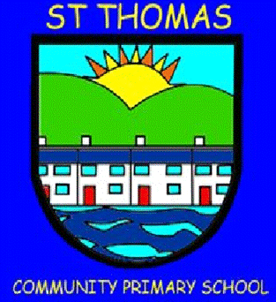
St Thomas Community Primary School
Newsletter
Summer Term 2, 2025 Issue 72 – 17/07/25
Head Teacher’s Message

Best wishes,

Year 5 – Residential to Llanion Cover
Our Year 5 had an incredible overnight stay in West Wales. At Llanion Cove, the children
partcipated in a range
of adventurous
activties and also
visited Pembroke
Castle. A big thank
you to all the adults
who accompanied
them.

Year 6 – Residential to Manor Adventure
Our Year 6 also had an amazing weekend at Manor Adventure. They took part in a range of new experiences including archery, paddle boarding, rifle shooting and climbing to name a few. We were so impressed with their attitude!

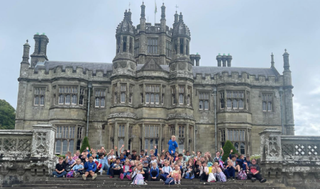
Summer Trips
This half-term has
seen the children
provided with lots of
fantastic opportunities.
These have included
trips to the Waterfront Museum, Margam Park, Cinema Trips, Copper Jack boat tours and local park visits. We would also like to thank all volunteers that helped attend the trips.

Share Your Strength
Thanks to our previous Chair of Governors, Mrs. Scannell, we have been able to celebrate our children’s strength with a competition. The entries were phenomenal and included art, writing, music and dance. We are so proud of our
children and the strengths that they have showcased.

Year 6 Gorge Walking and Lliw Valley Reservoir
At the start of the year, our Year 6 children were very generously donated £4,500 to allow them to participate in an outdoor learning experience. The phenomenal donation was made by the Old dy’vorians as part of their Dynevor Days concept. This was used to fund our Year 6 Gorge Walking trip. The trip was absolutely fantastic with so many laughs and giggles.

Sports Days
All children from Flying Start to Year 6 participated
in Sports Days this term. We were lucky with the weather and it was great
to see so many children
enjoying the experience.
Thank you to those of
you who were able to attend.

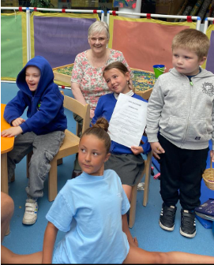

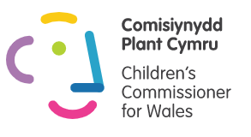

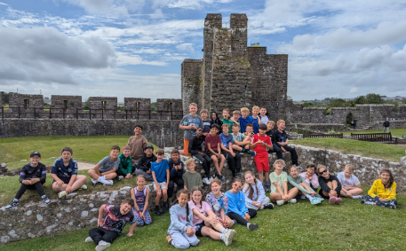

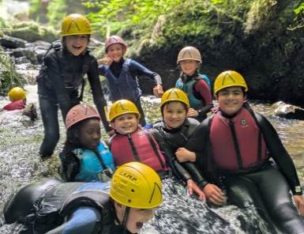


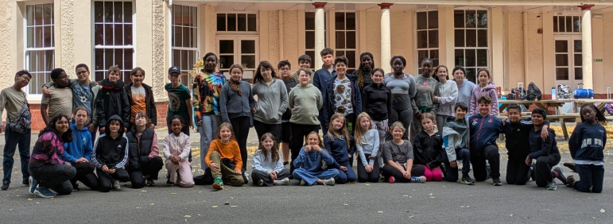



Get regular updates on the Dojo app.

We support Children’s Rights and the UNCRC.

St Thomas Community Primary School
Newsletter
Summer Term 2, 2025 Issue 72 – 17/07/25
Nursery Teddy Bears‘ Picnic and Graduation
This week, our Nursery children have celebrated the end of school year with a Teddy Bears‘ Picnic and a Graduation ceremony for the children moving into Reception in September. It was wonderful to see how much they have grown and how ready they are for full time school.

Greg Rees Shield
A team of our pupils participated in a tournament organised by Tre Uchaf Primary School. Children took part in football, netball and rugby games with children from other schools. We were really impressed with their commitment and proud of their efforts. Well done all!

Musical Celebrations
There have been a number of musical events this half term. Children performed with violins, flutes, toots and Year 2 sang and peformed percussion activities in school. Year 3 also visited the
Brangwyn Hall, for a Year 3 Pbuzz bonanza in which they showcased their talents. Well done to
all!
Free Books
For the second year running, the school has benefitted from £1900 worth of new books from the National Literacy Trust, Young Readers programme. This has meant new books for school and 3 books for every children in Year 4 and 5 to take home.

Goodbye and good luck to Mrs. Blyth, Mrs. Rees, Mr. Jowett and Mr. McCoy
This term, we unfortunately say goodbye to some of our staff. Mr. Jowett embarks on a universoty course whilst Mr. McCoy will move to a school closer to his family. Mrs. Blyth will also be taking a secondment to support the teaching of visually impaired learners while Mrs. Rees retires. We wish all of them the very best of lick and thank them for everything they have done for our St. Thomas family.

Goodbye and good luck, Year 6!
We also say goodbye to our amazing Year 6 for being simply awesome. It has been a pleasure having them as part of our school. We wish them all the very best!

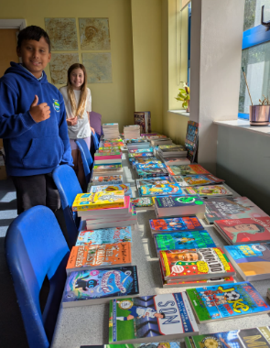

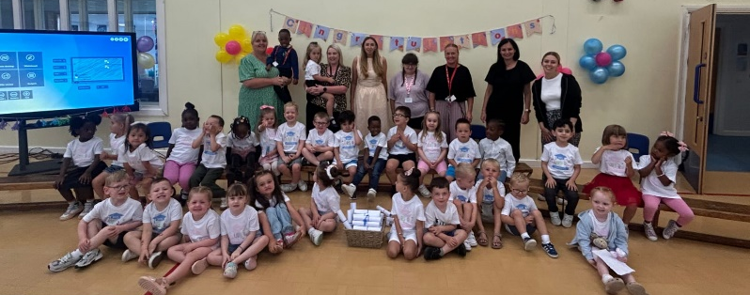

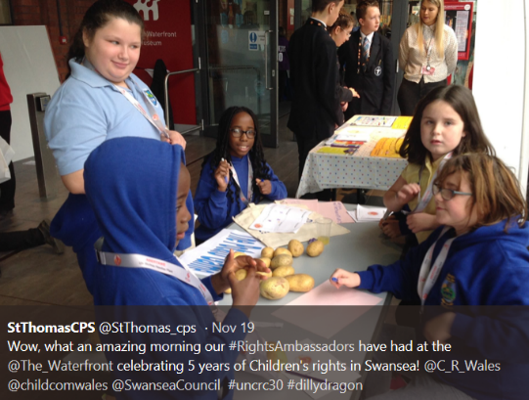

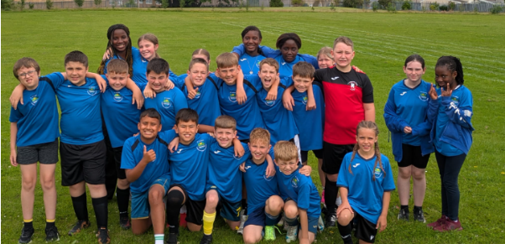

Attendance

Whole School Attendance

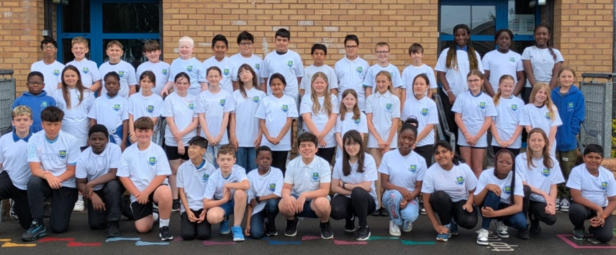

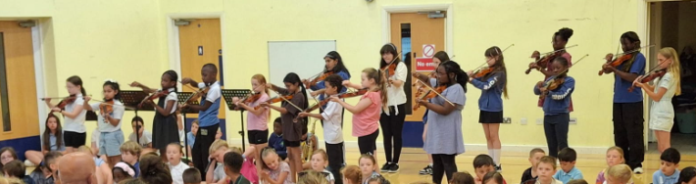
Have a lovely summer holiday and we will see you back in school on…
Tuesday 2nd September 2025
Breakfast from 8am / Registration at 8.50am

Important Dates

End of 24-25 School Year – Thursday 17th July, 2025
INSET Day – Monday 1st September, 2025
Children return to school – Tuesday 2nd September, 2025

Attendance Target for the Year – ?%

Attendance this year – ?%
We didn’t hit our target, but we still increased our attendance by 2% which is definitely a step in the right direction. Well done!

