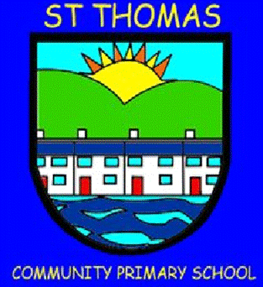
St Thomas Community Primary School
Newsletter
Spring Term 1, 2025 Issue 69 – 21/02/25

Head Teacher’s Message

We find ourselves once again at the halfway point of the school year and as you can see from this newsletter, a lot has gone on this half term. It has been great to see the children engaging so well with their learning and making progress as a result. I hope they all enjoy a well deserved rest over half term!

Best wishes,

The Fight– We’re Creative Finalists (again!)

Following on from Year 6’s Theatr Na nog visit last term, to see a performance called, ‘The Fight’, the children’s learning was submitted as an entry for the Caroline Davies Creative Learning Award. We are delighted to say that we are one of three finalists and have been invited to an awards ceremony on March 12th.
Regardless of the outcome, to be
finalists is a brilliant achievement.

Year 2 Music Sessions

As part of our Music
offer, Mrs Stallwood’s
class have been working
hard this half term with
Mrs Gibbs, our visiting Music teacher. Here the children are concentrating and playing glockenspiels. A big thank you to Mrs Gibbs for her help!

Fa la la – Welsh Learners

Year 2 have also been
developing their Welsh
language skills through
songs. They recently attended
a Fa La La singing an event
at Trallwn Primary
School, with children from
Other schools and we were
thrilled with their enthusiasm
and effort. Bendigedig!

St Thomas Savers Bank

This half term we have
continued with our savings
club, ‘St Thomas Savers’,
in partnership with the
Credit Union. A team of
pupils have been trained to offer a savings club to children from Year 3 – 6. It has been great to see over 40 children start saving with our new club and it was amazing to hear Claire from the Credit Union be so complimentary of our pupils. If any Year 3 – 6 pupils are interested in learning financial skills and want to start saving, please contact the school office for a registration form. Our St Thomas Savers Bank will run every Tuesday morning in The Hangout.

Year 5 - Kilvey Hill

Year 5 enjoyed exploring
the great outdoors and
visiting Kilvey Hill.
They made the most out of
this fantastic space on our doorstep, building dens and engaging in teamwork activities. As the weather improves we will be revisiting the hill a lot more!

Year 3 St. Fagan’s Trip

To help with their learning our
Year 3 classes went to St. Fagan’s
to learn about Celtic life. The
children visited a roundhouse,
met Celts and learnt about the
Celtic way of life.

Zack Franks – Thank You
For many years, we have been lucky to have Zack Franks help our children and families with dance. He has led lessons in school and run sessions for our Wellbeing Wednesdays. Zack has also helped choreograph dances for our
Christmas shows and End of Year celebrations. Zack will be leaving us this half term but we are sure he will be back in some capacity in the future.

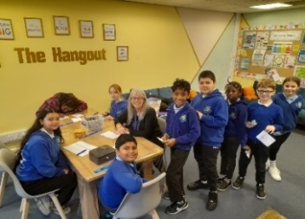

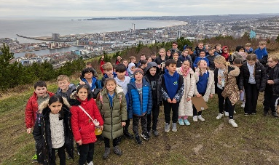


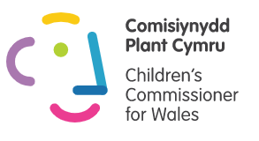

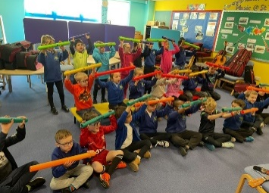





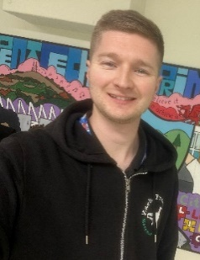
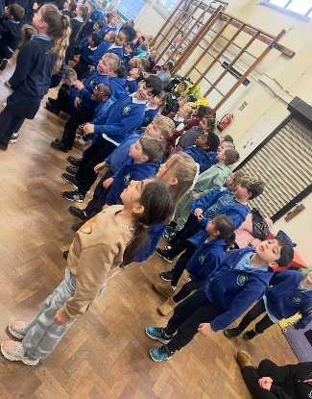
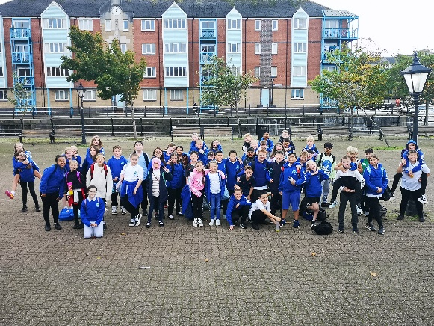


Sign up to the Dojo app for regular updates.

We support Children’s Rights and the UNCRC.

St Thomas Community Primary School
Newsletter
Spring Term 1, 2025 Issue 69 – 21/02/25
Football, Football and more Football!

This term, there has been loads of football opportunities undertaken by the boys and girls in school. We have had children represent the school at Pure football for various boys’ and girls’ festivals, watched our Year 6 children play friendly matches against Danygraig, and also some Year 5 children took part in Pure Football’s Shooting Rig Challenge. Well done to all the children who participated. We look forward to more opportunities next half term.

Year 4 – Outdoor Learning – Jersey Park

Our Year 4 children took
part in outdoor learning
at Jersey Park. They celebrated
nature and the local
environment whilst having
lots of fun!

Ty Victoria Nursing Home – Valentine’s Cards

Some Year 5 children spent their
creative time spreading the love on
Valentine’s Day by making
special cards and gifts to share
with residents at Ty Victoria
Nursing Home. This was a lovely
thing to do and certainly put a
smile on people’s faces!

Chinese New Year

Nursery, Reception and Year 1 have
been learning to appreciate each other’s
cultures by exploring and celebrating
Chinese New Year. They have engaged
brilliantly in food tasting and craft
activities.

Author Visit – Catherine Fisher

In partnership with St. Thomas library, our Year 6 children participated in an author visit to meet Catherine Fisher. This was a fantastic experience for our children to
meet a published author and to ask valuable questions. It really helped to inspire the children’s creativity with regards to their writing.

The Big ‘Have Your Say’ Conversation

A number of our School Council children attended another Big Conversation at the National Waterfront Museum with other children from across Swansea. They had the opportunity to comment on a range of issues that will help shape Swansea’s future.

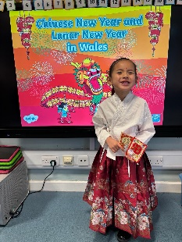

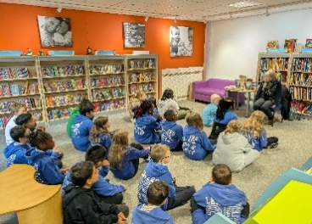

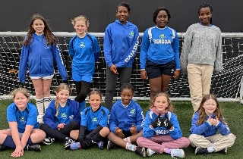
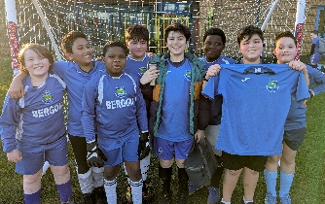

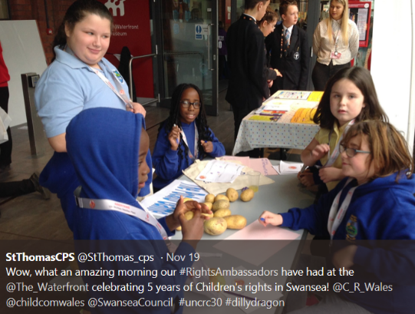

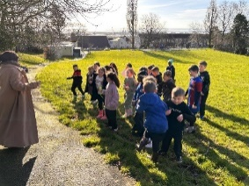

Attendance

Whole School Attendance

Important Dates

Start of Spring Term 2 – Monday 3rd March, 2025
Fluoride Varnishing – Nursery to Year 2 – 4th March, 2025
World Book Day – Thursday 6th March, 2025
Eisteddfod Celebration – Friday 7th March, 2025
Neurodiversity Week – 17th March, 2025
British Sign Language Week – 17th March, 2025
Parent/Carer Consultations – 31st March – 11th April
Outdoor Learning – Reception – 13th and 17th March. 2025
Y3 & 4 Boys’ Pure Football – Friday, 14th March, 2025
Last day of Spring Term – Friday 11th April, 2025
INSET – Monday 28th April, 2025 – NO SCHOOL for children
Start of Summer Term – Tuesday 29th April, 2025

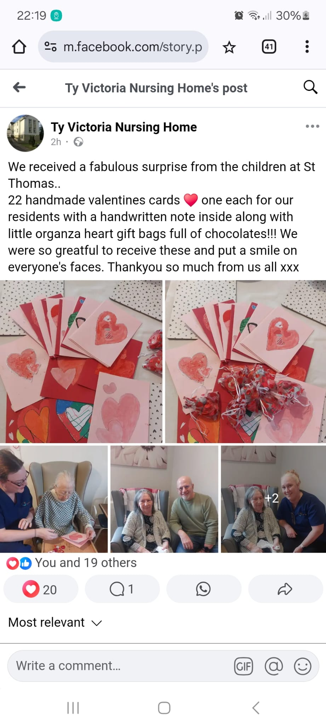
#
Have a lovely half term and we will
see you back in school on…

Monday 3rd March, 2025

Attendance Target for the Year – 92 %

Attendance so far this year – %

We were hit by a lot of bugs before Christmas but attendance has improved this half term. Please ensure your child is in school as much as possible to help them progress in their learning

