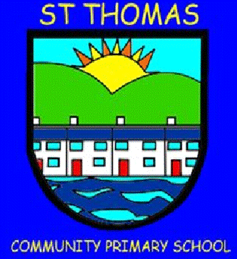
St Thomas Community Primary School
Newsletter
Spring Term 2, 2025 Issue 70 – 11/04/25
Head Teacher’s Message

The weeks really do fly and here we are at the end of the Spring Term already! Thank your support this half term and it was lovely that so many of you took up the opportunity to attend consultations with your child’s class teacher. We really value this engagement from home. Please remember, if you think we can be of any help, please speak to us. I hope you all have a lovely Easter break and we will see the childre back in school on April 29th!

Best wishes,

Caroline Davies Creative Learning Award
In celebration of their creative learning, Year 6 were shortlisted for an award based on a drama performance they went to see in October last year, called The Fight. We are
pleased to say that they came third which is a fantastic achievement. Well done to all involved.

Comic Relief
A huge thank you to everyone who helped us raise £??? for Comic Relief. It was great to
see the red noses fly out and we even had someone lucky enough to find a special gold one!

Let’s Celebrate - Musical event – Y ear 2 – 4
Three classes who received music sessions from external music teachers, had the chance to showcase their talent to families. It was so lovely to see them have the confidence to perform their newly acquired and developing skills!

Reception Recycling Fashion Show
Designers in the making! Last week, our Reception classes put on a phenomenal fashion show for all their families. Linking with their topic of recycling, the children all made clothes to wear out of recyclable materials. It truly was a memorable experience.

Outdoor Learning with UWTSD
Students from the University of Wales, Trinity St David recently supported Reception and Year 1 to engage in outdoor learning. The children thoroughly enjoyed the experience - getting muddy, building structures and generally having lots of fun! It was lovely to watch them. A big thank you to the university for continuing to give our children this opportunity.

Year 5 Mindfulness
Our Year 5 classes are currently undertaking a Mindfulness programme with Mrs Roffey, called Paws b. Children have been learning about brain development, being present and developing techniques to support their emotions. Mrs Roffey has been very impressed with the children’s attitude. Keep up the great work, Year 5!

World Book Day
In early March, we celebrated our love of reading as a school. It was brilliant to see the children dress as their favourite book characters and to see the teachers swap to read a story to a different class.

Year 6 - Basic First Aid and British Sign Language
Thanks to New Directions, our Year 6 children took part in introductory sessions for British Sign Language and Basic First Aid. Both are extremely important life skills and it was
great to see so much enthusiasm on display.

Year 3 – 6 – Recycling Assembly
To spread the importance of recycling, we
had a special assembly teaching us about
how to recycle properly and why it is important. We even got a visit from
Sammy Seagull! Reduce, Reuse, Recycle!

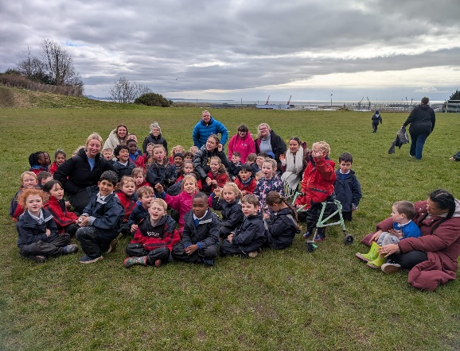

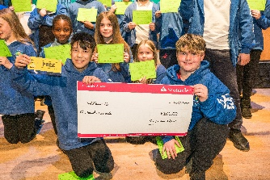

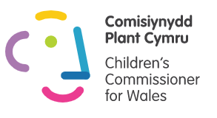



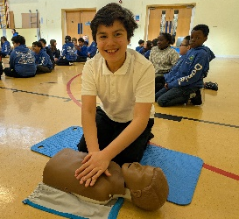

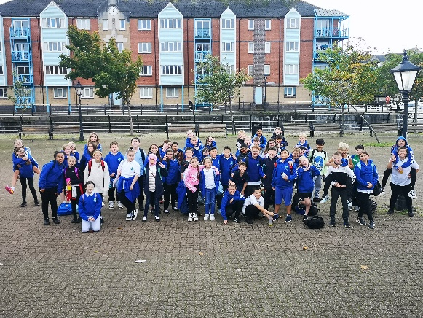
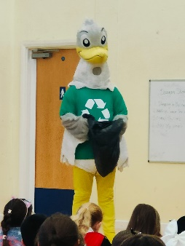
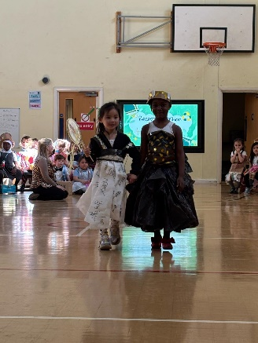


Ensure you are signed up to Dojo for regular updates

We support Children’s Rights and the UNCRC.

St Thomas Community Primary School
Newsletter
Spring Term 2, 2024 Issue 64 – 22/03/24
Sporting Events
This half term, girls and boys have played in a range of football teams as part of festivals, and all have represented our school superbly.

Poet Visit – Connor Allen
Children in Years 3 - 6 had the opportunity to work with a poet called Connor Allen. Conner used to be the Children’s Poet Laureate so it was really special to have him join us. As well as leading a poetry workshop with the children, Connor also shared
his experiences of racism. We are very grateful to have him share his experiences and talent with our children and hopefully inspire the next Children’s Laureate!

Dogs Trust
Over recent weeks, we have been lucky to have Dogs Trust come in and speak to all of our pupils. We learnt about how to look after dogs and how to keep them and ourselves safe.

Year 6 – Bouncing Back Programme
Recently, our Year 6 pupils
attended the Swansea.com
Stadium for a celebration
event. Working with Action
for Children and Ospreys in
the Community, the children took part in a range of practical sessions to develop our mental and physical health. We even got to have a tour of the stadium!

Big Conversation
A group of School Council pupils represented the school superbly at a recent event in the Waterfront Museum. Whilst joining children from other schools, our pupils engaged in purposeful discussions around equality and why it is important.

St David’s Day Eisteddfodd
In early March, we celebrated
St. David’s Day in style,
with our annual Eisteddfod.
Children gathered points for
their houses through a range of competitions, such as poetry, art and home learning. Well done to all the children for their superb efforts! Ardderchog i pawb!

Cefn Hengoed Cluster Games
To support transition to secondary school, a number of our children competed in the annual cluster games, participating in football and netball events. The children represented the school fantastically with some brilliant results.

Easter Escape Room Fun!
To promote life skills such as problem solving, working with others, time management, and communication we have introduced Escape Rooms to our curriculum for children in Years 3 -6. This current one is Easter themed and the children have had an eggcellent time taking part in our cabin! It's great that children have had an input in the design too – independent learning in action!

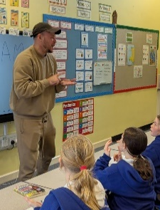

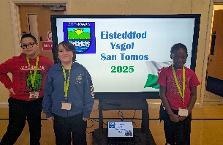

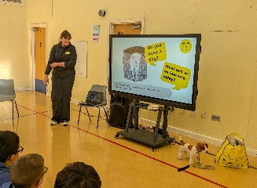
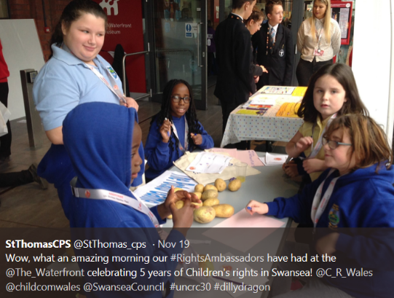

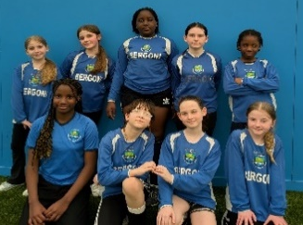
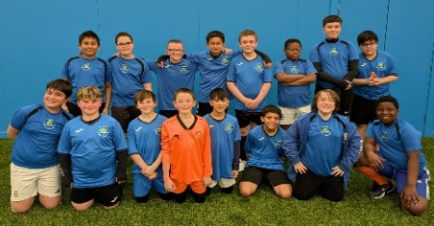

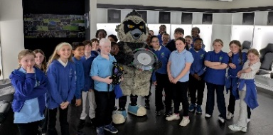
Attendance

Whole School Attendance

#
Important Dates

INSET – NO SCHOOL FOR PUPILS – Monday, 28th April
Start of Summer Term 1 – Tuesday, 29th April 2025
Bank Holiday – NO SCHOOL - Monday, 5th May 2025
Reception Height, Weight and Vision Screening – 15/5/24
School Photo Day – Thursday, 15th May, 2025
End of half term – Friday, 23rd May,2024

Attendance Target for the Year – 93%
Attendance so far this year – 90.8%
Our attendance has taken a bit of a hit this term and we have fallen behind where we were last year. Please ensure your child has the best opportunity to learn by being in school as much as possible next term. Attendance letters will go out this week and meetings will be held where there remains ongoing concern.

Have a lovely break and we will
see you back in school on…

Tuesday, 29th April 2025

